The Passing Away of Wing Chee Lam (FA57)

The Association announces with deep regret the passing away of Wing Chee Lam (林永持) on Feb 17, 2021. Wing Chee is from the class of 1957 and a long-time member of QESAAUSA.
Wing Chee is survived by wife Veronica, son Joey, daughter-in-law and two grandkids.

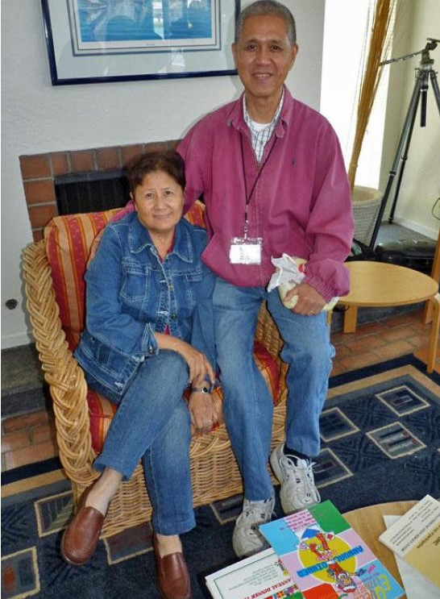
Wing Chee with wife Veronica

