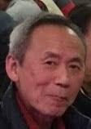
RIP - LIN CHUA
The Association is saddened to be the bearer of a piece of bad news. Lin Chua, 林礎, passed away February 10, 2022. Lin, of the class of 1959, lived in Cupertino, California and had been a long-time member of QESAAUSA. He once served in the Board of Directors of the Association as the Membership Secretary in the Board (2001-2002).
After QES, Lin pursued further studies in the University of California, Berkeley and graduated with a BSME and MSME. He also had a MSEE and MBA from the University of Santa Clara, California.
His career was in R&D development and management of the Disk Drive industry and management of electronics and high-tech companies. He had worked for IBM of San Jose, Ampex of Redwood City and Tulin Technology of San Jose. The last few years of his career was spent as Management Consultant for Tulin Technology.
Lin liked to spend his spare time on tennis and golf.
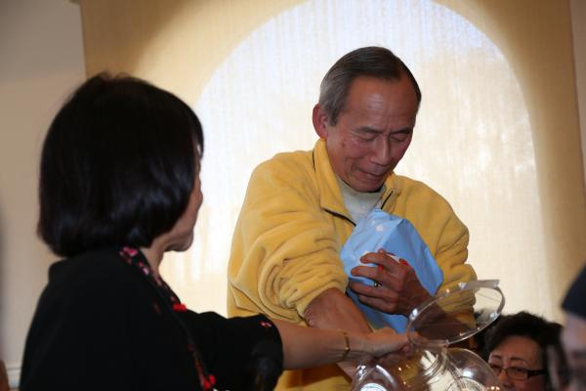
Lin pictured above picking up the winning ticket for the raffle draw in the 2015 AGM and lunch.

